Tessellations Vocabulary
- Horizontal | Going side-to-side, like the horizon.
- Vertical | In an up-down position, upright
- Diagonal | Non-mathematical use is a slanted line.  In math, diagonal means a line going from one corner to another opposite corner. | 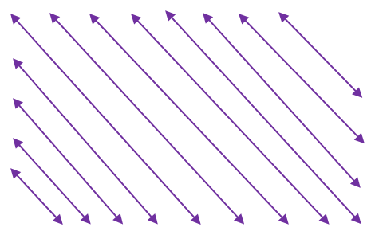  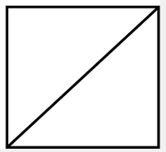
- Gradation | Gradual Change- Any process or change taking place through a series of stages in a gradual manner.
- Rhombus | A 4-sided flat shape with straight sides where all sides have equal length.
- Hexagon | A 6-sided polygon
- Symmetry | The property of being made of same-shape parts that face each other. Folding the shape on a line will line up parts that match.
- Asymmetry | Opposite of Symmetry, where there is no regularity of corresponding parts.
- Congruent | When two figures have the same shape and size. | 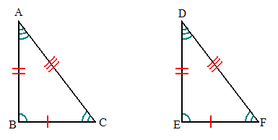
- Random | Without order. Not able to be predicted. Happening by chance. | 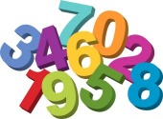
- Anomaly | A deviation from the common rule, type, arrangement, or form.
- Pattern | Things that are arranged following a specific rule.
- Structure | Anything composed of parts arranged together in a specific way. | 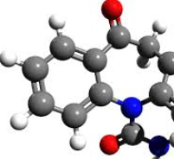
- Orientation | An object’s relative position | 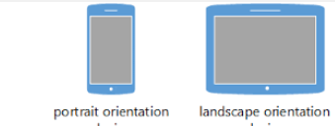
- Tessellation | A pattern of shapes that fit together without any overlap | 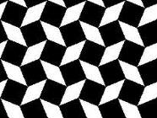
- Mosaic | A picture or decoration made of small, usually colored pieces of inlaid stone, glass, etc. | 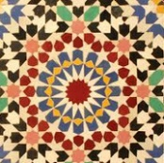
- Quilt | A blanket, made of layers of fabric and stitched in patterns. | 