Tessellations Word Search

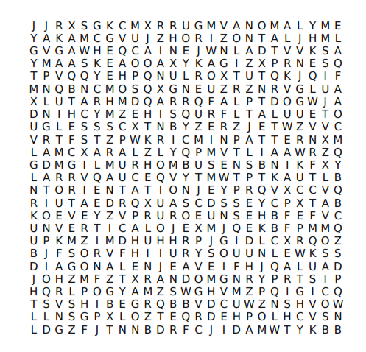

Tessellation Crystal

Asymmetry Anomaly

Symmetry Horizontal

Rhombus Pattern

Gradation Mosaic

Quilt Structure

Orientation Vertical

Congruent Hexagon

Random Diagonal