BITMAP

A bitmap tells which pixels to color. The map begins at the bottom. The number of rows and columns is the resolution.
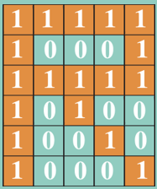
R = 10001 10010 10100 11111 10001 11111

Understanding Bitmaps
- Draw a bitmap to create the letter P. Write the bitmap for it.

